**H&S Advisor**

**Candidate Information Pack**

**March 2017**

**A message from the Chief Executive**

Thank you for showing an interest in this position.

The Impact Report which is part of the information available to candidates will give you a flavour of the type of work we deliver and the impact we make. This includes having worked with over 10,000 people last year, with over three quarters of these being under the age of 25. We know our work with young people is genuinely transformational and we are all passionate about continuing to grow this area. However we also know that to achieve this, our commercial operations have to be sound.

2017 will see us focusing on ensuring our training revenues drive sufficient surplus into the charity to underpin our future sustainability and invest in our transformational Sea.Change activities. With the pressure on local government and the public sector as a whole to reduce their expenditure and make budget cuts, it is essential now more than ever that UKSA has a self-sustaining model on which to grow and be able to invest in the charity and achieve our strategy and vision.

We have an exciting time ahead and we are looking for individuals who can be pro-active within a fast past and unique environment; who excel at being part of a team, thrive at solving problems and have a desire to be part of UKSA’s future and in turn support young people who most need our help.

I look forward to your application.



**Ben Willows**

**Chief Executive**

**About UKSA**

We are a youth charity that uses the power of the sea to transform the lives of thousands of young people each year, from all around the UK. The charity was formed in 1987 by Noel and Sylvia Lister who wanted to educate and enrich the lives of young people, using their experience of the sea, including the infinite challenges and gifts it offers, and the power it holds to make change. Nearly thirty years on, this remarkable ethos remains at the heart of UKSA. Our activities fall into two areas:

**Sea.Change**

We provide life-changing opportunities to schools and groups, disadvantaged and disaffected young people who are not in education, employment or training (NEETs) and young offenders. A common theme for many of these individuals is the low expectation they have of themselves and we challenge them to transform and to create opportunities for themselves.

**Sea.Careers**

We are the world’s largest provider of marine training, ranging from watersports instructor, through to training officers working on vessels up to 3,000 gross tonnes. This work cross-subsidises our ‘Sea Change’ activities.

We are proud of the large number of students who leave us to start their first jobs in the maritime industry, and go onto a lifetime of opportunity.

**Application process**

Please complete the application form which is available on the website and email it to [recruitment@uksa.org](mailto:recruitment@uksa.org)

**Closing date:** Monday 27 March 2017

**Date for interview/selection:**  Wednesday 5 April 2017, at UKSA - Cowes

**Job Description**

**Job Title** Health and Safety Advisor

**Reporting to:** Head of HR

**Banding:** The banding for this role is B4

**Key Objectives:**

* Oversee, advise, provide information and administer the Health and Safety (‘H&S’) processes to comply with Health & Safety Executive Management Standards, statutory requirements, policy and best practice relating to H&S, fire and emergency planning
* Provide effective, accurate, timely and pro-active support and advice to Managers in the management and administration of H&S meetings, practices and procedures
* Liaise with H&S Executive and other external enforcement agencies and authorities, with regard revised information, policies and procedural implementation
* Report statistical information to the H&S management team with appropriate dissemination throughout UKSA

**The duties and responsibilities will include, but are not limited to:**

* Communicate and promote H&S information and practices throughout the organisation, in particular to Managers, and keeping policies and procedures up to date;
* Ensure current staff receive the correct H&S training relevant to their role, including induction for new employees
* Work with the managers to ensure all records for H&S, including risk assessments, are up to date, centrally filed, and periodically reviewed;
* Ensure the training and shore side departments have up to date and accurate H&S records of standing operating procedures, recorded incidents, accident and near misses, records of training to staff and instructors
* Ensuring sufficient first aid supplies are maintained
* Manage and maintain site accident books;
* Undertake H&S audits and site inspections as directed
* Assist in the investigation of accidents, incidents, dangerous occurrences, near misses and other incidents
* Attend and contribute to monthly H&S Training and Shore side meetings and ensure minutes/follow up actions are produced and tracked.
* Attend and contribute to monthly H&S Management meetings.
* Analyse data and prepare management reports highlighting trends, issues, threats and opportunities and present to the H&S management team, supporting commitment to action.

**Team Performance**

* Prepare for and take full part in 1-1 reviews with manager;
* Ensure adherence to all policies and procedures and promoting the Vision, Purpose and Values of UKSA.

**Health and Safety**

* Operate on a daily basis which demonstrates a duty to take care of your own health and safety and that of others who may be affected by your actions at work.
* Co-operate with employers and co-workers to help everyone meet their legal requirements.

**Role Profile:**

* **Essential Qualifications/Experience**
* Graduate status with IOSH and membership
* NEBOSH General Certificate or equivalent
* 2-5 years’ experience as H&S Advisor in a similar environment or industry
* Have a good understanding of health and safety at work in relation to policy development, risk assessment, administration and record keeping
* Have good IT knowledge, particularly Word and Excel
* **Personal Attributes**
* Customer focused and strong ability to deliver pro-active solutions to meet the needs of the business.
* Able to prioritise effectively and meet targets
* Demonstrate a commitment to ongoing CPD and or interest in working towards CMIOSH
* Possess excellent communication skills, and be able to liaise and influence at all levels within the organisation

**This job description will be reviewed from time to time and may be updated as agreed**

**H&S Advisor - Key terms and conditions**

|  |  |
| --- | --- |
| **Salary** | £14,000 per annum  (Equating to the full time equivalent of £21,000 per annum)  Payable on 28th of each month |
| **Annual Leave** | Pro rata to 25 days plus Bank Holidays  The leave year runs from 1 December to 30 November |
| **Working Hours** | The hours for this role are 25 hours per week  (Working mornings over 5 days) |
| **Location** | This role is primarily based at UKSA, Arctic Road, Cowes. |
| **Pension** | National Employment Savings Trust  Employer contribution of 1% |
| **Sickness** | In the first three months of employment you are entitled to Statutory Sick Pay only, thereafter UKSA will pay up to 6 casual or “waiting” days in any rolling calendar year. |
| **Notice Period** | During the probationary period notice will be 1 week and after that 4 weeks notice will be required. |
| **Probationary Period** | 6 months |
| **Disclosure and Barring Service check** | Not applicable |

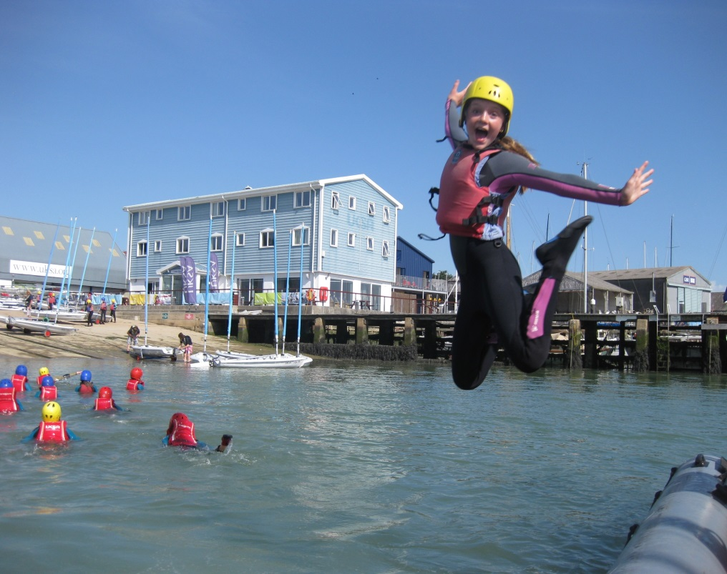

We are UKSA

This is how we work

**Staff code of conduct:** We are one team – collaboration across departments and functions is critical to the success of our organisation and the excellent care and quality of delivery to our clients. Professionalism should flow through everything we do and customer care should be our priority; Professional presentation of staff, site, delivery and service is at the heart of all we do.

**Our clients see everything we do**

Respect and support your colleagues – “that’s not my job” doesn’t exist at UKSA

Our organisation expects us to support each other and work together. Our values support this:

* **Challenge, have fun and smile**
* **We take care of ourselves, those around us and this place**
* **Be part of who we are and help others do the same**
* **Tell the truth, hear the truth, act truthfully**
* **‘If not you, who? If not now, when?’**

**UKSA Dress code**

* Staff must adhere to our dress code at all times
* Front of house, maintenance, housekeeping, instructors and lecturers will wear branded uniform
* Smart office wear is expected for all other staff
* Tailored shorts are acceptable in the summer
* Neat board shorts are acceptable for watersports instructors
* No flip flops for any staff.

**Phones**

* We have a phone policy – it is expected that all staff are aware of it and work within the policy
* Calls should be answered within 3 rings
* Everyone should take their own calls – **it maybe a customer**
* If messages are taken, caller information must be accurate and details should be emailed and passed on
* Employees must take ownership of their answerphone messages
* Personal mobile phones should not be used during working hours – unless it’s agreed with your manager or a personal issue that is urgent
* Every office will have an overflow line

**Email and letters**

* Respond to all correspondence within 3 days
* If you cannot reply fully within that period, contact should be made confirming a realistic timeframe of when a response will be made (maximum of 10 working days)
* Only CC someone into an email if necessary and note that the copied individual/s do not need to action anything
* Conversations should not be taking place over email; email should primarily be used to pass over information – if a discussion is required, face to face or phone communication is preferable
* Email is not there make a record and collect evidence of someone not doing something
* All staff should use the UKSA standard out of office message when not in the office
* Respond to all meeting requests and where possible, meetings should not to be scheduled in over lunch time.
* Where possible, planned meetings / 1-1’s should not be cancelled at short notice without prior discussion

**Complaints**

* Acknowledge the complaint within 24 hours and provide a timeframe for a full response if unable to provide one immediately
* Provide a full response within 10 working days
* Extend the timeframe only where absolutely necessary and an explanation for the delay should be provided
* If you are the person a complaint is raised with then it is incumbent on you to ensure the complaint is resolved to a conclusion

**Work Stations**

* Free tea and coffee will be provided to all staff in the Lister Kitchen
* A microwave can be used by all staff in the Lister Kitchen
* Hot food is not to be consumed at desks
* There should be no refreshment areas in offices
* Desks / work stations should be left tidy and organised at the end of each day
* Office cleaning standards will be upheld

**Smoking**

* Staff are only able to smoke in the designated smoking area on site
* Staff are not allowed to smoke outside the front gates and in front of Victory. Staff are expected to ask students not to do this
* There is no smoking on yachts when alongside in marinas (anywhere)
* Staff are not permitted to smoke when out on corporate sailing days

**Site, Classrooms & Accommodation**

* The rear car park area behind the swimming pool needs to be kept tidy, and available for groups parking when required – it is not used to store staff personal boats, or equipment
* **All staff** are expected to adhere to the lecture room user guide – **all staff** must support this by leaving rooms to the correct standard and layout; it’s everyone's responsibility
* If a piece of equipment is left / found in the wrong place then return it to its correct location
* Evening duty staff will set the rooms up and site appropriately for the following day
* Site and fleet workshops must be kept clean, safe and tidy at all times

**Timelines and objectives**

* Completing work on time is vital for success – timelines for completion of work / projects must always be agreed. If these cannot be met it is not acceptable to let them go past the agreed deadline without prior agreement
* All staff are expected to work within the UKSA objective framework and ensure this is updated and agreed with your manager

**Our Clients**

* Meeting and greeting our clients is critically important – All staff are expected to make our clients feel welcomed and cared for at all times
* Say good bye! Showing our clients that we care and we want them to come back to us is very important; we must always say goodbye and please come again