**National Citizen Service (NCS) Programme Lead**

**Candidate Information Pack**

**A message from the Chief Executive**

Thank you for showing an interest in this position.

The Impact Report which is part of the information available to candidates will give you a flavour of the type of work we deliver and the impact we make. This includes having worked with over 10,000 people last year, with over three quarters of these being under the age of 25. We know our work with young people is genuinely transformational and we are all passionate about continuing to grow this area. However we also know that to achieve this our commercial operations have to be sound.

2016/17 will see us focusing on ensuring our training revenues drive sufficient surplus into the charity to underpin our future sustainability and invest in our transformational Sea.Change activities. With the pressure on local government and the public sector as a whole to reduce their expenditure and make budget cuts, it is essential now more than ever that UKSA has a self-sustaining model on which to grow and be able to invest in the charity and achieve our strategy and vision.

We have an exciting time ahead and we are looking for individuals who can be pro-active within a fast and unique environment; who excel at being part of a team, thrive at solving problems and have a desire to be part of UKSA’s future and in turn support young people who most need our help.

I look forward to your application.



**Ben Willows**

**Chief Executive**

**About UKSA**

We are a youth charity that uses the power of the sea to transform the lives of thousands of young people each year, from all around the UK. The charity was formed in 1987 by Noel and Sylvia Lister who wanted to educate and enrich the lives of young people, using their experience of the sea, including the infinite challenges and gifts it offers, and the power it holds to make change. Nearly thirty years on, this remarkable ethos remains at the heart of UKSA. Our activities fall into two areas:

**Sea.Change**

We provide life-changing opportunities to schools and groups, disadvantaged and disaffected young people who are not in education, employment or training (NEETs) and young offenders. A common theme for many of these individuals is the low expectation they have of themselves and we challenge them to transform and to create opportunities for themselves.

**Sea.Careers**

We are the world’s largest provider of marine training, ranging from watersports instructor, through to training officers working on vessels up to 3,000 gross tonnes. This work cross-subsidises our ‘Sea Change’ activities.

We are proud of the large number of students who leave us to start their first jobs in the maritime industry, and go onto a lifetime of opportunity.

**Joining ‘NCS UKSA’**

National Citizen Service (NCS) is an unforgettable opportunity for 15-17 year old students. The aim is for participants to develop communication, teamwork, leadership and personal skills to prepare and assist them for their future; nationally more than 300,000 young people have participated in NCS. The programme has been proven vastly beneficial and as such has received support from the UK government and Royal Family.

We are currently seeking to recruit NCS Programme Leads for summer 2017. As an NCS programme Lead you will be required to facilitate the delivery of the programme. The programme consists of 4 elements; adventure, skills, social interaction and community involvement with a final graduation ceremony on completion.

The job involves:

* Facilitating programme objectives to a variety of learners aged 15-17;
* Maintaining accurate records and monitor learners’ progression;
* Delivery of planned and prepared differentiated sessions from pre-conceived scheme/s of work and necessary programme criterion;
* Maintaining high levels of safe working practices, following UKSA’s policies and procedures

**Application Process**

Please complete the application form which is available on our website and email it to [recruitment@uksa.org](mailto:recruitment@uksa.org)

**Closing date:** Monday 24 April 2017

**Date for interview:** Thursday 4th May **or** Friday 5th May 2017 at UKSA, Cowes

**Information for successful applicants:**

**Mandatory staff training:** 29th - 31st May 2017 inclusive, at UKSA

*Please note there is likely to be flexibility for these training dates to take place on alternative dates.*

**Three waves of available contract dates include:**

1. 17.07.17 – 11.08.17
2. 24.07.17 – 18.08.17
3. 07.08.17 – 01.09.17

**Mandatory student graduation ceremony:** 09.09.17

**Job Description – NCS Programme Lead**

**Reporting to:** Education Co-Ordinator

**Banding:** The banding for this role is B5

**Key Objectives:**

* **To provide exceptional standards of delivery to all UKSA clients**
* **To perform the role of programme lead at all times**
* **To ensure the safety of students at all times**
* **To comply with UKSA Standard Operating Procedures, governing bodies and the law**
* **To give guidance and mentor students throughout the programme**

**The duties and responsibilities will include, but are not limited to:**

* Providing a strong customer focus at all times.
* Ensuring the safety of everyone under your supervision.
* Engaging and building positive relationships with young people to provide effective support on a one to one or group basis to achieve agreed outcomes
* Delivering evening activity sessions.
* Participation in two week overnight residential with NCS Participates
* To complete data returns as needed to provide statistical and qualitative feedback about the NCS programme throughout its duration
* Attending staff meetings, with all relevant information for the day’s activities contained within a session plans.
* Helping maintain a clean working centre including classrooms aswell as the entire fleet.
* Ensuring adherence to all policies and procedures and promoting the Vision, Purpose and Values of UKSA

**Health and Safety**

* Operate on a daily basis which demonstrates a duty to take care of your own health and safety and that of others who may be affected by your actions at work.
* Co-operate with employers and co-workers to help everyone meet their legal requirements.

**Team Performance**

* Prepare for and take full part in 1-1 reviews with line manager
* Ensuring adherence to all policies and procedures and promoting the Vision, Purpose and Values of UKSA

**Profile:**

**Essential Qualifications/Experience**

* Life experience and extensive practice of leading and working with groups of young people and able to both motivate them and command their respect
* Experience of planning, coordinating, delivering programmes for 16 – 17 year olds and what engages them
* Team working experience - working within a team to achieve desired outcomes
* An understanding of and a commitment to equal opportunities issues both in the workplace and the wider community
* Good organisational and decision making skills
* Ability to handle challenging situations and problem-solving skills
* Ownership – ability to take ownership of tasked areas of responsibility
* Experience of volunteering or working with young people of the target age group
* Previous knowledge of the NCS programme and/or experience working on the NCS
* Full driving licence **essential**
* Good IT skills
* Enhanced Child Workforce DBS check clearance **essential**

**Personal Attributes**

* Is committed to the mission and goal of NCS UKSA.
* Is passionate about young people and promoting social mobility of those from marginalised groups. Interacting with Others: Shows respect and understanding of diverse points of view and demonstrates understanding in daily work and decision-making, as well as defusing conflicts that arise from misunderstanding.
* Examines own biases and behaviours to avoid stereotypical responses and does not discriminate against any young person or group.
* Seeks to understand the ideas of others and supports others who are dealing with difficulties and problems.
* Is willing to take on new challenges and seeks to go above and beyond desired outcome.
* Gives constructive feedback to others in a way they can accept and understand. Seeks to do more than what is required of them if it benefits the team and the organisation.

**NCS Programme Lead- Terms and Conditions**

|  |  |
| --- | --- |
| **Salary** | £18,000 Pro-rata  Payable on 28th of each month |
| **Annual Leave** | Pro rata to 28 days inclusive of bank holidays to reflect duration of fixed term contract |
| **Working Hours** | 40 hours per week over 5 days including evenings and weekends |
| **Location** | 1 Week located at Swanage, 3 Weeks Located at UKSA, Arctic Road, Cowes |
| **Accommodation** | Week 1 and 2 will be included in rate of employment; week 3 and 4 are available as follows:  Shared accommodation on site will be provided at a cost of £42.00 per week  (in line with Accommodation Offset rates updated annually in October)  Optional meals at £40.00 per week. |
| **Training** | 29th-31st May 2017 |
| **Pension** | N/a |
| **Sickness** | Statutory Sick Pay only |
| **Notice Period** | 1 week |
| **Probationary Period** | Throughout Fixed Term Contract |
| **Dislclosure and Barring Service check** | Enhanced Child Workforce DBS check clearance required - MUST be in place before starting work with UKSA |

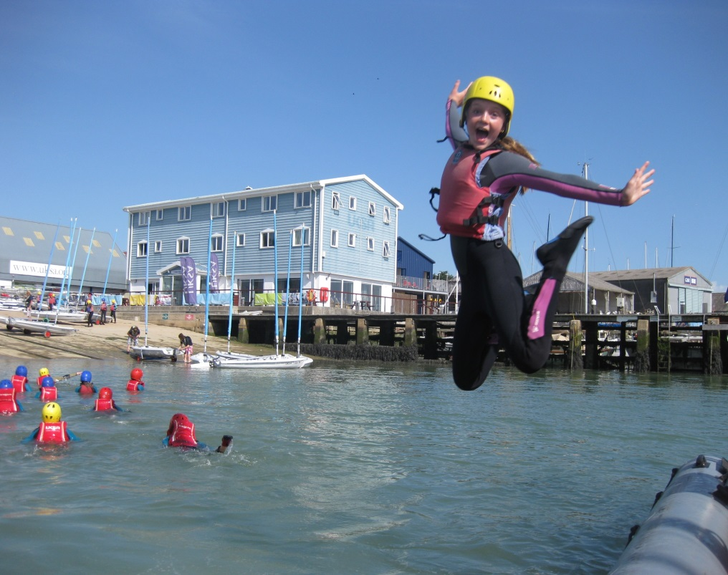

We are UKSA

This is how we work

**Staff code of conduct:** We are one team – collaboration across departments and functions is critical to the success of our organisation and the excellent care and quality of delivery to our clients. Professionalism should flow through everything we do and customer care should be our priority; Professional presentation of staff, site, delivery and service is at the heart of all we do.

**Our clients see everything we do**

Respect and support your colleagues – “that’s not my job” doesn’t exist at UKSA

Our organisation expects us to support each other and work together. Our values support this:

* **Challenge, have fun and smile**
* **We take care of ourselves, those around us and this place**
* **Be part of who we are and help others do the same**
* **Tell the truth, hear the truth, act truthfully**
* **‘If not you, who? If not now, when?’**

**UKSA Dress code**

* Staff must adhere to our dress code at all times
* Front of house, maintenance, housekeeping, instructors and lecturers will wear branded uniform
* Smart office wear is expected for all other staff
* Tailored shorts are acceptable in the summer
* Neat board shorts are acceptable for watersports instructors
* No flip flops for any staff.

**Phones**

* We have a phone policy – it is expected that all staff are aware of it and work within the policy
* Calls should be answered within 3 rings
* Everyone should take their own calls – **it maybe a customer**
* If messages are taken, caller information must be accurate and details should be emailed and passed on
* Employees must take ownership of their answerphone messages
* Personal mobile phones should not be used during working hours – unless it’s agreed with your manager or a personal issue that is urgent
* Every office will have an overflow line

**Email and letters**

* Respond to all correspondence within 3 days
* If you cannot reply fully within that period, contact should be made confirming a realistic timeframe of when a response will be made (maximum of 10 working days)
* Only CC someone into an email if necessary and note that the copied individual/s do not need to action anything
* Conversations should not be taking place over email; email should primarily be used to pass over information – if a discussion is required, face to face or phone communication is preferable
* Email is not there make a record and collect evidence of someone not doing something
* All staff should use the UKSA standard out of office message when not in the office
* Respond to all meeting requests and where possible, meetings should not to be scheduled in over lunch time.
* Where possible, planned meetings / 1-1’s should not be cancelled at short notice without prior discussion

**Complaints**

* Acknowledge the complaint within 24 hours and provide a timeframe for a full response if unable to provide one immediately
* Provide a full response within 10 working days
* Extend the timeframe only where absolutely necessary and an explanation for the delay should be provided
* If you are the person a complaint is raised with then it is incumbent on you to ensure the complaint is resolved to a conclusion

**Work Stations**

* Free tea and coffee will be provided to all staff in the Lister Kitchen
* A microwave can be used by all staff in the Lister Kitchen
* Hot food is not to be consumed at desks
* There should be no refreshment areas in offices
* Desks / work stations should be left tidy and organised at the end of each day
* Office cleaning standards will be upheld

**Smoking**

* Staff are only able to smoke in the designated smoking area on site
* Staff are not allowed to smoke outside the front gates and in front of Victory. Staff are expected to ask students not to do this
* There is no smoking on yachts when alongside in marinas (anywhere)
* Staff are not permitted to smoke when out on corporate sailing days

**Site, Classrooms & Accommodation**

* The rear car park area behind the swimming pool needs to be kept tidy, and available for groups parking when required – it is not used to store staff personal boats, or equipment
* **All staff** are expected to adhere to the lecture room user guide – **all staff** must support this by leaving rooms to the correct standard and layout; it’s everyone's responsibility
* If a piece of equipment is left / found in the wrong place then return it to its correct location
* Evening duty staff will set the rooms up and site appropriately for the following day
* Site and fleet workshops must be kept clean, safe and tidy at all times

**Timelines and objectives**

* Completing work on time is vital for success – timelines for completion of work / projects must always be agreed. If these cannot be met it is not acceptable to let them go past the agreed deadline without prior agreement
* All staff are expected to work within the UKSA objective framework and ensure this is updated and agreed with your manager

**Our Clients**

* Meeting and greeting our clients is critically important – All staff are expected to make our clients feel welcomed and cared for at all times
* Say good bye! Showing our clients that we care and we want them to come back to us is very important; we must always say goodbye and please come again