**Pool Lifeguard**

**Candidate Information Pack**

**March 2017**

**A message from the Chief Executive**

Thank you for showing an interest in this position.

At UKSA we have worked with over 10,000 people last year, with over three quarters of these being under the age of 25. We know our work with young people is genuinely transformational and we are all passionate about continuing to grow this area. However we also know that to achieve this our commercial operations have to be sound. We have an exciting time ahead and we are looking for individuals who can be pro-active within a fast past and unique environment; who excel at being part of a team, thrive at solving problems and have a desire to be part of UKSA’s future and in turn support young people who most need our help.

Here at UKSA, watersports is at the heart of everything we do and naturally, so is the safety of our visitors and students using our facilities. We now have an opening available for a qualified **Pool Lifeguard** to join our team to ensure the safety of all pool users.

We’re looking for someone who has no trouble working off of their own initiative as there will be a lot of lone working in this position. Due to the nature of the role it’s important that you’re a confident decision maker while being able to quickly assess a variety of situations. Safety isn’t the only thing that’s paramount in this position – cleanliness is equally as important! You will be responsible for storing Chemicals and ensuring they are handled and used in the accurate manner, including maintaining the correct balance within the pool.

Cleanliness will include ensuring the changing rooms and toilet areas are kept clean, tidy and well stocked, as well as surrounding areas of course, including the pool area. This part of the role will require you to be hands on and meticulous with an excellent attention to detail. Routine inspections and checks on the pumps and boilers are regularly carried out and it will be down to you to make sure these happen as and when the time comes.

What makes UKSA so special is the support we receive from our customers, which is why we go above and beyond to provide a fantastic service no matter what. As part of our team, you will need to equally have the same focus on the customer and their overall experience when visiting UKSA.

This position is **permanent and will be part time, working a minimum of 10 hours per week** with the potential to increase this depending on demand. Your hours may fall over any day of the week and will include bank holidays. It’s vital that you hold an RLSS Qualification as well as having experience in the use of pool chemicals and testing in order to be considered for this position, in addition to an Enhanced valid DBS check.

I look forward to your application.



**Ben Willows**

**Chief Executive**

**About UKSA**

We are a youth charity that uses the power of the sea to transform the lives of thousands of young people each year, from all around the UK. The charity was formed in 1987 by Noel and Sylvia Lister who wanted to educate and enrich the lives of young people, using their experience of the sea, including the infinite challenges and gifts it offers, and the power it holds to make change. Nearly thirty years on, this remarkable ethos remains at the heart of UKSA. Our activities fall into two areas:

**Sea.Change**

We provide life-changing opportunities to schools and groups, disadvantaged and disaffected young people who are not in education, employment or training (NEETs) and young offenders. A common theme for many of these individuals is the low expectation they have of themselves and we challenge them to transform and to create opportunities for themselves.

**Sea.Careers**

We are the world’s largest provider of marine training, ranging from watersports instructor, through to training officers working on vessels up to 3,000 gross tonnes. This work cross-subsidises our ‘Sea Change’ activities.

We are proud of the large number of students who leave us to start their first jobs in the maritime industry, and go onto a lifetime of opportunity.

**Application process**

Please complete the application form which is available on the website and email it to [recruitment@uksa.org](mailto:recruitment@uksa.org)

**Closing date: 5pm Wednesday 15 March 2017**

**Date for interview/selection: Tuesday 21 March 2017**

**Job Title Pool Lifeguard**

**Reporting to: Facilities Manager**

*Day-to-day reporting to Pool Supervisor*

**Key Objectives:**

* **To ensure a high level of safety cover for persons using the pool**
* **To ensure correct chemical levels are maintained**
* **To ensure a high level of cleanliness at all times**

**The duties and responsibilities will include, but are not limited to:**

Ensuring:

* The safety of all pool users by being vigilant and proactive at all times;
* The correct chemical balance is maintained;
* Chemicals are stored, handled and used in the correct manner;
* The pool, hall, plant room, and changing rooms are kept clean and tidy;
* The toilet areas are clean and stocked at all times;
* All defects are reported to maintenance; ensuring priorities are highlighted;
* Routine inspections and checks on pumps and boilers are regularly carried out;
* Strong customer focus at all times;
* Prepare for and take full part in 1-1 reviews with line manager;
* Adherence to UKSA policies and procedures;
* Promoting the Vision, Mission and Values of UKSA .

**Profile:**

* **Essential Qualifications/Experience**
* **Must** possess RLSS pool lifeguard qualification
* Experience in the use of pool chemicals and testing
* Good IT skills
* Valid Enhanced DBS check
* **Personal Attributes**
* Highly motivated and able to work on own initiative;
* Confident decision maker while being able to quickly asses a variety of situations;
* Strong desire to deliver excellent customer service.

|  |  |  |
| --- | --- | --- |
| **Authorised by:** |  |  |
|  | **Director of Finance and Human Resources** | **Date** |
|  |  |  |
|  | **Manager** | **Date** |

**Pool Lifeguard - Key terms and conditions**

|  |  |
| --- | --- |
| **Salary** | National Living Wage Wage  Payable on 28th of each month |
| **Annual Leave** | Pro rata to 28 days including Bank Holidays  The leave year runs from 1 December to 30 November. |
| **Working Hours** | The hours for this role are 10 hours per week over 5 days.  There will be a variable working pattern based on the needs of the role, and will include weekend, evening and bank holiday working. |
| **Location** | This role is based at UKSA, Arctic Road, Cowes. |
| **Pension** | National Employment Savings Trust  Employer contribution of 1% |
| **Sickness** | In the first three months of employment you are entitled to Statutory Sick Pay only, thereafter UKSA will pay up to 6 casual or “waiting” days in any rolling calendar year. |
| **Notice Period** | During the probationary period notice will be 1 week and after that 4 weeks notice will be required. |
| **Probationary Period** | 6 months |
| **Disclosure and Barring Service check** | Valid Enhanced DBS check clearance - essential |

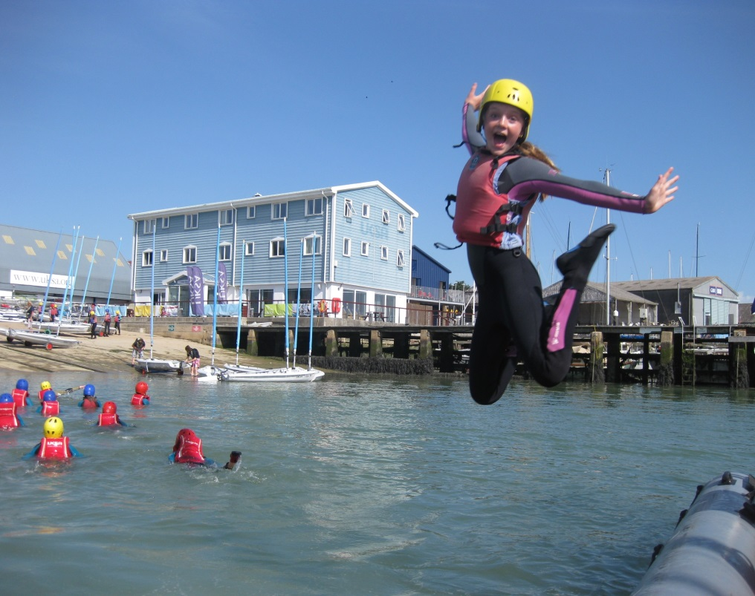

We are UKSA

This is how we work

**Staff code of conduct:** We are one team – collaboration across departments and functions is critical to the success of our organisation and the excellent care and quality of delivery to our clients. Professionalism should flow through everything we do and customer care should be our priority; Professional presentation of staff, site, delivery and service is at the heart of all we do.

**Our clients see everything we do**

Respect and support your colleagues – “that’s not my job” doesn’t exist at UKSA

Our organisation expects us to support each other and work together. Our values support this:

* **Challenge, have fun and smile**
* **We take care of ourselves, those around us and this place**
* **Be part of who we are and help others do the same**
* **Tell the truth, hear the truth, act truthfully**
* **‘If not you, who? If not now, when?’**

**UKSA Dress code**

* Staff must adhere to our dress code at all times
* Front of house, maintenance, housekeeping, instructors and lecturers will wear branded uniform
* Smart office wear is expected for all other staff
* Tailored shorts are acceptable in the summer
* Neat board shorts are acceptable for watersports instructors
* No flip flops for any staff.

**Phones**

* We have a phone policy – it is expected that all staff are aware of it and work within the policy
* Calls should be answered within 3 rings
* Everyone should take their own calls – **it maybe a customer**
* If messages are taken, caller information must be accurate and details should be emailed and passed on
* Employees must take ownership of their answerphone messages
* Personal mobile phones should not be used during working hours – unless it’s agreed with your manager or a personal issue that is urgent
* Every office will have an overflow line

**Email and letters**

* Respond to all correspondence within 3 days
* If you cannot reply fully within that period, contact should be made confirming a realistic timeframe of when a response will be made (maximum of 10 working days)
* Only CC someone into an email if necessary and note that the copied individual/s do not need to action anything
* Conversations should not be taking place over email; email should primarily be used to pass over information – if a discussion is required, face to face or phone communication is preferable
* Email is not there make a record and collect evidence of someone not doing something
* All staff should use the UKSA standard out of office message when not in the office
* Respond to all meeting requests and where possible, meetings should not to be scheduled in over lunch time.
* Where possible, planned meetings / 1-1’s should not be cancelled at short notice without prior discussion

**Complaints**

* Acknowledge the complaint within 24 hours and provide a timeframe for a full response if unable to provide one immediately
* Provide a full response within 10 working days
* Extend the timeframe only where absolutely necessary and an explanation for the delay should be provided
* If you are the person a complaint is raised with then it is incumbent on you to ensure the complaint is resolved to a conclusion

**Work Stations**

* Free tea and coffee will be provided to all staff in the Lister Kitchen
* A microwave can be used by all staff in the Lister Kitchen
* Hot food is not to be consumed at desks
* There should be no refreshment areas in offices
* Desks / work stations should be left tidy and organised at the end of each day
* Office cleaning standards will be upheld

**Smoking**

* Staff are only able to smoke in the designated smoking area on site
* Staff are not allowed to smoke outside the front gates and in front of Victory. Staff are expected to ask students not to do this
* There is no smoking on yachts when alongside in marinas (anywhere)
* Staff are not permitted to smoke when out on corporate sailing days

**Site, Classrooms & Accommodation**

* The rear car park area behind the swimming pool needs to be kept tidy, and available for groups parking when required – it is not used to store staff personal boats, or equipment
* **All staff** are expected to adhere to the lecture room user guide – **all staff** must support this by leaving rooms to the correct standard and layout; it’s everyone's responsibility
* If a piece of equipment is left / found in the wrong place then return it to its correct location
* Evening duty staff will set the rooms up and site appropriately for the following day
* Site and fleet workshops must be kept clean, safe and tidy at all times

**Timelines and objectives**

* Completing work on time is vital for success – timelines for completion of work / projects must always be agreed. If these cannot be met it is not acceptable to let them go past the agreed deadline without prior agreement
* All staff are expected to work within the UKSA objective framework and ensure this is updated and agreed with your manager

**Our Clients**

* Meeting and greeting our clients is critically important – All staff are expected to make our clients feel welcomed and cared for at all times
* Say good bye! Showing our clients that we care and we want them to come back to us is very important; we must always say goodbye and please come again