**Senior Watersports Instructor**

**Candidate Information Pack**

**A message from the Chief Executive**

Thank you for showing an interest in this position.

The Impact Report which is part of the information available to candidates will give you a flavour of the type of work we deliver and the impact we make. This includes having worked with over 10,000 people last year, with over three quarters of these being under the age of 25. We know our work with young people is genuinely transformational and we are all passionate about continuing to grow this area. However we also know that to achieve this our commercial operations have to be sound.

2016/17 will see us focusing on ensuring our training revenues drive sufficient surplus into the charity to underpin our future sustainability and invest in our transformational Sea.Change activities. With the pressure on local government and the public sector as a whole to reduce their expenditure and make budget cuts, it is essential now more than ever that UKSA has a self-sustaining model on which to grow and be able to invest in the charity and achieve our strategy and vision.

We have an exciting time ahead and we are looking for individuals who can be pro-active within a fast past and unique environment; who excel at being part of a team, thrive at solving problems and have a desire to be part of UKSA’s future and in turn support young people who most need our help.

I look forward to your application.



**Ben Willows**

**Chief Executive**

**About UKSA**

We are a youth charity that uses the power of the sea to transform the lives of thousands of young people each year, from all around the UK. The charity was formed in 1987 by Noel and Sylvia Lister who wanted to educate and enrich the lives of young people, using their experience of the sea, including the infinite challenges and gifts it offers, and the power it holds to make change. Nearly thirty years on, this remarkable ethos remains at the heart of UKSA. Our activities fall into two areas:

**Sea.Change**

We provide life-changing opportunities to schools and groups, disadvantaged and disaffected young people who are not in education, employment or training (NEETs) and young offenders. A common theme for many of these individuals is the low expectation they have of themselves and we challenge them to transform and to create opportunities for themselves.

**Sea.Careers**

We are the world’s largest provider of marine training, ranging from watersports instructor, through to training officers working on vessels up to 3,000 gross tonnes. This work cross-subsidises our ‘Sea Change’ activities.

We are proud of the large number of students who leave us to start their first jobs in the maritime industry, and go onto a lifetime of opportunity.

**Joining our Watersports Team**

We are currently seeking to recruit senior instructors for 2017 to add experience and guidance to our Watersports Team of up to 50 Instructors in the height of season with the potential of extending through the winter.

The job involves:

* teaching a variety of Watersports disciplines to a wide range of customers on our RYA Adult and Youth short courses;
* Delivery of UKSA Schools and Groups taster sessions;
* Delivery of the long term Career Instructor Training courses UKSA offers.

You will have the opportunity to develop your personal skills and add to your qualifications.

**Application Process**

Please complete the application form which is available on the website and email it to [recruitment@uksa.org](mailto:recruitment@uksa.org)

Closing date: Friday 17 March 2017

Date for interview: Week commencing 27.3.127 at UKSA, Cowes

**Job Description - Senior Watersports Instructor**

**Reporting to:** Youth Training Manager

**Banding:**  The banding for this role is B5

**Key Objectives:**

* **To provide exceptional standards of delivery afloat & ashore to all UKSA clients**
* **To perform the role of senior instructor at all times whilst afloat and ashore**
* **To ensure the safety of students at all times**
* **To comply with UKSA Standard Operating Procedures, governing bodies and the law**
* **To give guide and mentor seasonal watersports instuctors**

**The duties and responsibilities will include, but are not limited to:**

* Providing a strong customer focus at all times.
* Ensuring the safety of everyone under your supervision.
* Attending staff meetings, with all relevant information for your full days sessions wrote down with session plans.
* Delivering a high quality of supervision / education to groups assigned to you.
* Delivering evening activity sessions.
* Helping to maintain a clean working centre including classrooms aswell as the entire fleet.
* Helping to develop the centre with new ideas and improvements to current courses and operational systems.
* To perform the role of Senior Instructor afloat, day and evening instructor in charge when scheldued
* Attending UKSA open days when required.
* To support the Management Training staff with any other tasks required.
* Ensuring adherence to all policies and procedures and promoting the Vision, Purpose and Values of UKSA

**Profile:**

**Essential Qualifications**

* + RYA Senior Instructor Dinghy or Windsurf
  + Keelboat and Multihull Endorsement
  + Powerboat instructor
  + First Aid qualification
  + Driving License

**Desirable qualifications**

* + UKCC / BCU level 1 coach
  + SUP Instructor
  + Racing Instructor
  + Current DBS check certificate
  + Experience in team building games & other land based activities such as orienteering, Soft Archery Etc.

**Personal Attributes** (other personal qualities)

* + Ability to communicate well
  + Relevant teaching experience
  + Ability to motivate and educate
  + Good team player
  + Work well underpressure and have the ability to deal with short notice changes.

**This job description will be reviewed from time to time and may be updated as agreed**

**Senior Watersports Instructor - Terms and Conditions**

|  |  |
| --- | --- |
| **Salary** | Up to £18,000  Payable on 28th of each month |
| **Annual Leave** | 20 days plus Bank Holidays  The leave year runs from 1 December to 30 November. |
| **Working Hours** | 48 hours per week over 6 days including evenings and weekends |
| **Location** | This role is based at UKSA, Arctic Road, Cowes. |
| **Accommodation** | Shared accommodation on site will be provided at a cost of £42.00 per week (in line with Accommodation Offset rates updated annually in October)  Meals at £40.00 per week |
| **Training** | Opportunities will be provide to maintain and upgrade your qualifications |
| **Pension** | National Employment Savings Trust  Employer contribution of 1% |
| **Sickness** | In the first three months of employment you are entitled to Statutory Sick Pay only, thereafter UKSA will pay up to 6 casual or “waiting” days in any rolling calendar year. |
| **Notice Period** | During the probationary period notice will be 1 week and after that 4 weeks notice will be required. |
| **Probationary Period** | 6 months |
| **Dislclosure and Barring Service check** | Required - Needs to be in place before starting work with UKSA |

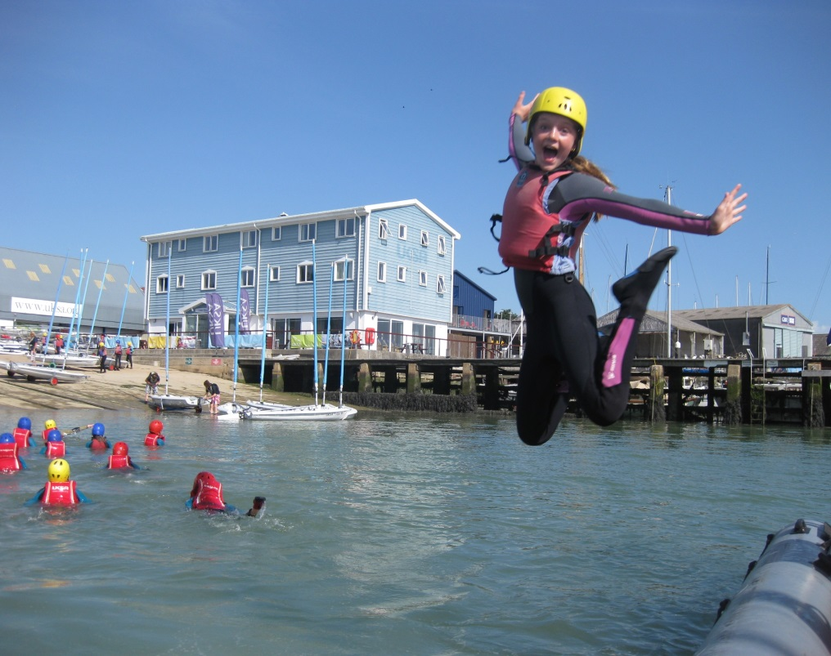

We are UKSA

This is how we work

**Staff code of conduct:** We are one team – collaboration across departments and functions is critical to the success of our organisation and the excellent care and quality of delivery to our clients. Professionalism should flow through everything we do and customer care should be our priority; Professional presentation of staff, site, delivery and service is at the heart of all we do.

**Our clients see everything we do**

Respect and support your colleagues – “that’s not my job” doesn’t exist at UKSA

Our organisation expects us to support each other and work together. Our values support this:

* **Challenge, have fun and smile**
* **We take care of ourselves, those around us and this place**
* **Be part of who we are and help others do the same**
* **Tell the truth, hear the truth, act truthfully**
* **‘If not you, who? If not now, when?’**

**UKSA Dress code**

* Staff must adhere to our dress code at all times
* Front of house, maintenance, housekeeping, instructors and lecturers will wear branded uniform
* Smart office wear is expected for all other staff
* Tailored shorts are acceptable in the summer
* Neat board shorts are acceptable for watersports instructors
* No flip flops for any staff.

**Phones**

* We have a phone policy – it is expected that all staff are aware of it and work within the policy
* Calls should be answered within 3 rings
* Everyone should take their own calls – **it maybe a customer**
* If messages are taken, caller information must be accurate and details should be emailed and passed on
* Employees must take ownership of their answerphone messages
* Personal mobile phones should not be used during working hours – unless it’s agreed with your manager or a personal issue that is urgent
* Every office will have an overflow line

**Email and letters**

* Respond to all correspondence within 3 days
* If you cannot reply fully within that period, contact should be made confirming a realistic timeframe of when a response will be made (maximum of 10 working days)
* Only CC someone into an email if necessary and note that the copied individual/s do not need to action anything
* Conversations should not be taking place over email; email should primarily be used to pass over information – if a discussion is required, face to face or phone communication is preferable
* Email is not there make a record and collect evidence of someone not doing something
* All staff should use the UKSA standard out of office message when not in the office
* Respond to all meeting requests and where possible, meetings should not to be scheduled in over lunch time.
* Where possible, planned meetings / 1-1’s should not be cancelled at short notice without prior discussion

**Complaints**

* Acknowledge the complaint within 24 hours and provide a timeframe for a full response if unable to provide one immediately
* Provide a full response within 10 working days
* Extend the timeframe only where absolutely necessary and an explanation for the delay should be provided
* If you are the person a complaint is raised with then it is incumbent on you to ensure the complaint is resolved to a conclusion

**Work Stations**

* Free tea and coffee will be provided to all staff in the Lister Kitchen
* A microwave can be used by all staff in the Lister Kitchen
* Hot food is not to be consumed at desks
* There should be no refreshment areas in offices
* Desks / work stations should be left tidy and organised at the end of each day
* Office cleaning standards will be upheld

**Smoking**

* Staff are only able to smoke in the designated smoking area on site
* Staff are not allowed to smoke outside the front gates and in front of Victory. Staff are expected to ask students not to do this
* There is no smoking on yachts when alongside in marinas (anywhere)
* Staff are not permitted to smoke when out on corporate sailing days

**Site, Classrooms & Accommodation**

* The rear car park area behind the swimming pool needs to be kept tidy, and available for groups parking when required – it is not used to store staff personal boats, or equipment
* **All staff** are expected to adhere to the lecture room user guide – **all staff** must support this by leaving rooms to the correct standard and layout; it’s everyone's responsibility
* If a piece of equipment is left / found in the wrong place then return it to its correct location
* Evening duty staff will set the rooms up and site appropriately for the following day
* Site and fleet workshops must be kept clean, safe and tidy at all times

**Timelines and objectives**

* Completing work on time is vital for success – timelines for completion of work / projects must always be agreed. If these cannot be met it is not acceptable to let them go past the agreed deadline without prior agreement
* All staff are expected to work within the UKSA objective framework and ensure this is updated and agreed with your manager

**Our Clients**

* Meeting and greeting our clients is critically important – All staff are expected to make our clients feel welcomed and cared for at all times
* Say good bye! Showing our clients that we care and we want them to come back to us is very important; we must always say goodbye and please come again