**Bar Person**

**Candidate Information Pack**

**May 2022**

**A message from our Chief Executive**

Thank you for showing an interest in this position with us.

UKSA inspires and supports children & young people to broaden their horizons through our life enhancing water-based adventures, education, and training for careers at sea. People are important to us, and we wouldn’t be able to do this without investing in our staff through continuous learning, delivering high performance and recognising excellence.

Founded nearly 35 years ago by philanthropist and entrepreneur, Noel Lister, and his wife Sylvia, over 150,000 people have benefited from our training and watersports programmes so far.

We believe all young people have a need but there are those that require greater support. Living through this period of austerity now, more than ever, the impact of COVID-19 has hit the schools and young people in the most disadvantaged areas the hardest. We know that many children and young people are missing out on life-changing opportunities because schools, local authorities and parents simply can’t afford to pay for them. The fragility of these young peoples’ mental health is exacerbated by a reliance on isolating social media ‘screen time’. Our outdoor learning programmes on the water are the antithesis to this.

In conjunction, we know that a career at sea can provide a life of adventure for those who are inspired to follow this path. We support all students with an aspiration for a long-term career in Maritime. Our aim is to remove both financial and social barriers to enable students from any background to be able to access UKSA programmes. We want them to achieve their best and gain life-changing experiences, qualifications, and careers.

The past two years have been an unexpected challenge for all but we enter 2022 with renewed optimism for the future. We will complete the construction of a new 136 bed accommodation building on site in Cowes, having raised £4.2m from donations to fund the project. The new building will enable UKSA to support 3,000 more young people and children into our programmes each year and we are all extremely excited about the start of this net phase of UKSA’s development.

Our new strategy is centred on extending our reach to more children and young people with the aim of helping them break free from their existing lives, the new ‘normal’ that COVID-19 has created and continue to prepare them for training and work.

We have an exciting time ahead. Adapting to COVID-19 has been a challenge, but one that UKSA has excelled at due to our amazing staff base and Employee Benefits & Recognition package.

If you have any questions, then please do not hesitate to contact me and I look forward to your application.



**Ben Willows**

**Chief Executive**

Below is a summary of our “Extended Reach” Strategy:

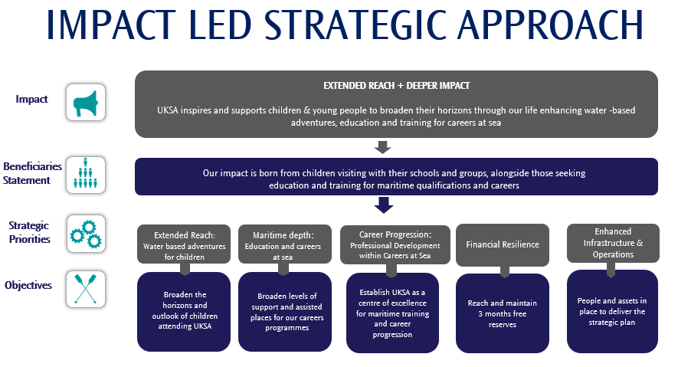

**About Us**

For over 30 years we have been helping children take their first steps on the water, launching careers, pushing personal training development with world-class training and offering transformational opportunities as a leading youth charity.

We provide adventures for 8,000 children and train over 1,500 professional career students to work within the growing global maritime sector each year. We support our students to believe in themselves by providing a hand up not a handout. Our professional education, mentoring and training pathways create exciting long-term maritime career opportunities empowering our students to succeed for themselves, their communities and society.

Our aim is to remove both financial and social barriers to enable students from any background to be able to access UKSA programmes. We want them to achieve their best and gain life-changing experiences, qualifications and careers.

In 2019 /20 we welcomed over 8,000 children and their leaders from 130 schools and groups across the UK. Our water-based programmes are designed to increase children’s life and leadership skills, build confidence and encourage teamwork with their peers. For many, UKSA is their first experience of the sea and being away from home.

Our world-class professional training and further education courses provide an alternative to university, we provide vocational training and qualifications to gain a career in the Maritime industry. We are also widely recognised throughout the world for our MCA and RYA training courses and are one of the world’s top providers of MCA yachting certificates.

As a charity, we do much more than deliver training and certification. We also offer a range of development programmes that help transform the lives of those from the most deprived areas of the UK.

If we sound like the place you want to be, and you are ready to make a difference, check out our application process below.

**Application Process**

Please complete the application form which is available on the website and email it to [recruitment@uksa.org](mailto:recruitment@uksa.org)

**Closing Date: 30th July 2022**

**Interview Date: TBC**

Shortlisted applicants will be invited to:

* Attend an interview

**Job Description:**

|  |  |
| --- | --- |
| **Job Description and Person Specification** | |
| **Job Title:** | Bar Person |
| **Reporting to:** | Head Chef |
| **Key Purpose:**   * **To ensure efficient customer service to promote all products in the bar** * **To remain professional and courteous whilst delivering excellent customer service** * **To keep all stock items and monies secure at all times** | |
| **Customer Service**   * Serving customers promptly and courteously * Motivated by a strong customer focus and desire to deliver the best service, deal with all students, visitor and staff bar requests in a timely and friendly manner | |
| **Venue Management**   * Be aware of and abide by current bar legislation * Ensuring the bar is open, and ready for customers, on time * Replenishing stock in the bar and vending machines, and presenting products in a suitable way * Ensuring that the bar and lounge areas are kept clean and tidy during opening hours * Ensuring that the bar is properly locked and secured at closing times | |
| **Financial processing**   * Ensuring that all money is kept secure at all times * Take payments for drinks and various items through the bar till, ensuring cash and PDQ transactions are processed correctly, and accompanying paperwork/finance records are complete and accurate * Clear tills/floats at shift close | |
| **Health & Safety**   * Demonstrate a duty of care of your own health and safety and that of other employees, co-workers, customers and other UKSA personnel to help everyone meet our share legal requirements. | |
| **Individual/Team Performance and Development (if not managing staff)**   * Ensure adherence to all policies and procedures and promote the Vision, Purpose and Values of UKSA * Understand your objectives and how these fit in with individual, team and business performance * Take responsibility for your own performance and development by preparing for and take full part in 1-1 reviews and appraisals with your manager | |
| **General**   * Comply with and promote UKSA equality and diversity, data protection and health & safety policies and procedures. * Make a commitment to deliver excellent customer service. | |
| This Job Description and Person Specification is not exhaustive and reasonable flexibility is expected to meet the changing needs of the business; it will be reviewed and may be updated from time to time in conjunction with the post holder. | |

**Person Specification**

|  |  |  |
| --- | --- | --- |
| **Person Specification** | | |
|  | **Essential** | **Desirable** |
| **Knowledge:** | Demonstrable understanding of bar licencing regulations | Cleaning and maintaining bar equipment to the correct standards including but not limited to draught beer-lines, pre/post mix soda equipment, coffee machines, fridges, microwaves and glass/dishwashers |
| **Qualifications:** |  | Food handling/hygiene certificate |
| **Experience:** | Experience of working in a similar environment  Competent with handling cash, use of cash register and float control |  |
| **Skills:** | Helpful and professional communication skills |  |

**Key Terms and Conditions**

|  |  |
| --- | --- |
| **Salary** | £19,760 per annum plus an Employee Benefits and Recognition Package  Payable on 28th of each month |
| **Annual Leave** | 25 days plus Bank Holidays  The leave year runs from 1 December to 30 November |
| **Working Hours** | 40 hours per week over 5 days  Flexibility in your hours will be required to include weekends, public holidays, and evenings as the needs of the business dictate |
| **Location** | You will be based onsite  UKSA  Arctic Road  Cowes  Isle of Wight  PO31 7PQ |
| **Pension** | National Employment Savings Trust  Employee contribution of 5%  Employer contribution of 3% |
| **Sickness** | In the first three months of employment you are entitled to Statutory Sick Pay only and thereafter in accordance with UKSA Policy |
| **Notice Period** | Probation period of 6 months  During the probationary period notice will be 1 month and after that 3 months’ notice will be required |
| **Disclosure and Barring Service check** | Enhanced DBS disclosure will be applicable |