**Chef**

**Candidate Information Pack**

**November 2022**

**A message from our Chief Executive**

Thank you for showing an interest in this position with us.

UKSA is a maritime youth charity and world-renowned training centre of excellence.  We inspire and support children and young people to broaden their horizons through inspirational water-based adventures, education and training for careers at sea.

People are important to us, and we wouldn’t be able to do this without our amazing team of staff. At UKSA we are a community, and our people are our greatest asset. We recognise and celebrate high performance, those who go the extra mile and those who live our core values.

Founded nearly 35 years ago by philanthropist and entrepreneur, Noel Lister, and his wife Sylvia, over 150,000 people have benefited from our training and watersports programmes so far.

We believe all young people have a need but there are those that require greater support. We know that many children and young people are missing out on life-changing opportunities because schools, local authorities and parents simply can’t afford to pay for them. The fragility of these young peoples’ mental health is exacerbated by a reliance on isolating social media ‘screen time’. Our outdoor learning programmes on the water are the antithesis to this.

In conjunction, we know that a career at sea can provide a life of adventure for those who are inspired to follow this path. We support all students with an aspiration for a long-term career in Maritime. Our aim is to remove both financial and social barriers to enable students from any background to be able to access UKSA programmes. We want them to achieve their best and gain life-changing experiences, qualifications, and careers.

Our strategy is centred on extending our reach to more children and young people with the aim of helping them break free from their existing lives and prepare them for training and work.

If you have any questions, then please do not hesitate to contact me and I look forward to your application.



**Ben Willows**

**Chief Executive**

Below is a summary of our “Extended Reach” Strategy:

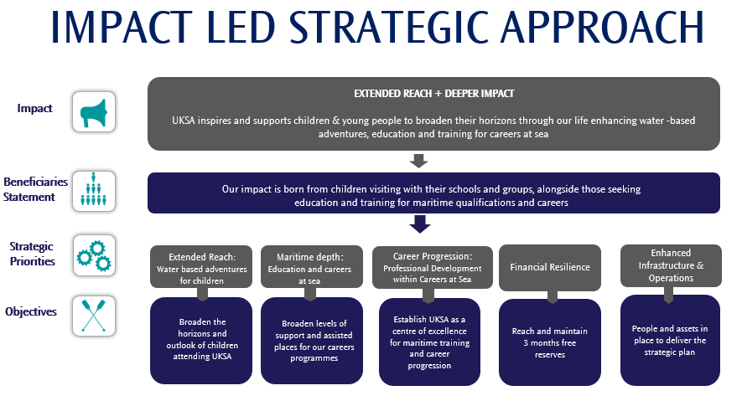

**About Us**

For over 35 years we have been helping children take their first steps on the water, launching careers, pushing personal development with world-class training, and offering transformational opportunities as a leading youth charity.

We welcome over 11,000 beneficiaries each year, providing adventures for children and young people and training professional career students to work within the growing global maritime sector each year. We support our students to believe in themselves by providing a hand up not a handout. Our professional education, mentoring and training pathways create exciting long-term maritime career opportunities empowering our students to succeed for themselves, their communities and society.

Our aim is to remove both financial and social barriers to enable students from any background to be able to access UKSA programmes. We want them to achieve their best and gain life-changing experiences, qualifications and careers.

We welcome over 8,000 children and their leaders from 130 schools and groups across the UK each year. Our water-based programmes are designed to increase children’s life and leadership skills, build confidence and encourage teamwork with their peers. For many, UKSA is their first experience of the sea and being away from home.

Our world-class professional training and further education courses provide an alternative to university. We provide vocational training and qualifications to gain a career in the Maritime industry. We are the world’s largest RYA training centre and widely recognised for both our RYA and MCA training courses. We are one of the world’s top providers of MCA yachting certificates.

As a charity, we do much more than deliver training and certification. We also offer a range of development programmes that help transform the lives of those from the most deprived areas of the UK.

If we sound like the place you want to be, and you are ready to make a difference, check out our application process below.

**Application Process**

Please complete the application form which is available on the website and email it to [recruitment@uksa.org](mailto:recruitment@uksa.org)

**Closing Date: 2nd December 2022**

**Interview Date: W/C 5th December 2022**

Shortlisted applicants will be invited to:

* Attend an interview

**Job Description:**

|  |  |
| --- | --- |
| **Job Description and Person Specification** | |
| **Job Title:** | Chef |
| **Reporting to:** | Head Chef |
| **Key Purpose:**   * **Support the team in delivering a high-quality food and menu service, both in our dining room and Wellness Café** * **To follow and adhere to all Health and Safety and Food Hygiene requirements according to UKSA policy** * **Promote a positive perception of the company at all times both internally & externally** | |
| **The duties and responsibilities will include, but are not limited to:**  **General**   * To take responsibility for the preparation, presentation and serving of all meals to an exceptional standard * Catering for UKSA’s Wellness Café and Bar * Catering for functions and events   **Specific**   * To prepare, cook and appropriately present meals and buffets for students, staff and functions as required * To ensure routine day to day as well as specialized cleaning of kitchen equipment, work surfaces, kitchen floors and storage areas * To ensure waste is controlled with regard to preparation and cooking * To maintain the highest levels of personal hygiene, food hygiene and safety * To manage and control all food, including receiving and checking stock, checking equipment and materials are used correctly, and closely monitoring portion control * To ensure that routine data is collected as required and that all daily checks, including temperature control during production, preparation, service and storage, are carried out correctly * To immediately report all accidents, near misses, damage or breakages * To actively assist in ensuring a five-star food hygiene rating * To ensure that the kitchen is opening and closed at the required times and secured when not in use * To undertake any other tasks appropriate with the duties and responsibilities of this post * To attend any relevant training sessions to ensure you are fully equipped to perform your role effectively | |
| **Financial & Performance Management**   * Work with the Head Chef/ Facilities and Services Manager to ensure the delivery of effective performance management, financial control and budget management for the catering department * Support the Head Chef/ Facilities and Services Manager with the preparation of annual budgets for income, expenditure, staffing and capital | |
| **Health & Safety**   * Demonstrate a duty of care of your own health and safety and that of other employees, co-workers, customers and other UKSA personnel to help everyone meet our share legal requirements * Ensure working practices are fully compliant with Food Hygiene and COSHH regulations * Ensure that all training and certifications remain valid and up to date | |
| **Individual/Team Performance and Development**   * Ensure adherence to all policies and procedures and promote the Vision, Purpose and Values of UKSA * Understand your objectives and how these fit in with individual, team and business performance * Take responsibility for your own performance and development by preparing for and take full part in 1-1 reviews and appraisals with your manager | |
| **General**   * Comply with and promote UKSA equality and diversity, data protection and health & safety policies and procedures * Make a commitment to deliver excellent customer service | |
| This Job Description and Person Specification is not exhuastive and reasonable flexibility is expected to meet the changing needs of the business; it will be reviewed and may be updated from time to time in conjuction with the post holder | |

**Person Specification**

|  |  |  |
| --- | --- | --- |
| **Person Specification** | | |
|  | **Essential** | **Desirable** |
| **Knowledge:** | * Ability to carry out all aspects of the role to a high standard at all times | * Experience of delivering a catering service in a high volume environment * Up to date with industry trends and creative menu planning skills * Experience of working in a residential environment * Awareness of safeguarding procedures |
| **Qualifications:** |  | * NVQ Level 1/2 in Catering & Hospitality or Equivalent * Certificate in Food Hygiene * Knowledge of COSHH regulations, safe storage and working practices |
| **Experience:** | * General Kitchen Experience * Budget monitoring | * Charitable sector experience * Supervisory experience * Ordering and stock taking, liaising with suppliers |
| **Skills:** | * Excellent social and verbal skills * Positive attitude * Approachable and flexible * A common sense approach * Must be able to work on own initiative, and with resilience * The ability to organise workload and multi-task * The ability to work without direct supervision * The ability to work as a member of a team * Excellent attendance and punctuality * Highly motivated with a drive to introduce continuous improvement * Reliable | * Supervisory skills e.g. delegation, decision making, listening and motivation skills |

**Key Terms and Conditions**

|  |  |
| --- | --- |
| **Salary** | £21,840 per annum plus an Employee Benefits and Recognition Package  Payable on 28th of each month |
| **Annual Leave** | 28 days inclusive of Bank Holidays  The leave year runs from 1 December to 30 November |
| **Working Hours** | 40 hours per week over 5 days  Flexibility in your hours will be required to include weekends, public holidays, and evenings as the needs of the business dictate |
| **Location** | You will be based onsite  UKSA  Arctic Road  Cowes  Isle of Wight  PO31 7PQ |
| **Pension** | National Employment Savings Trust  Employee contribution of 5%  Employer contribution of 3% |
| **Sickness** | In the first three months of employment you are entitled to Statutory Sick Pay only and thereafter in accordance with UKSA Policy |
| **Notice Period** | Probation period of 6 months  During the probationary period notice will be 1 month and after that 3 months’ notice will be required |
| **Disclosure and Barring Service check** | Basic DBS disclosure will be applicable |